Create the S3 bucket

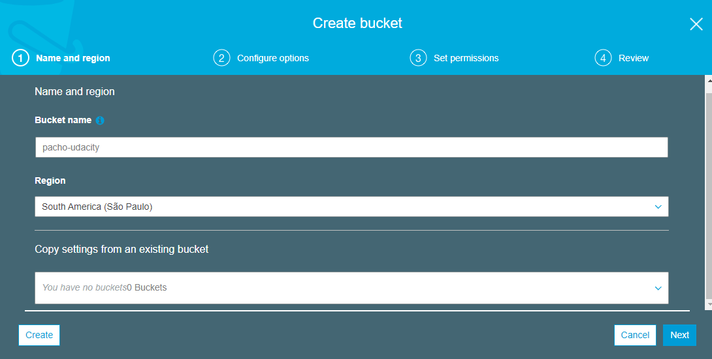

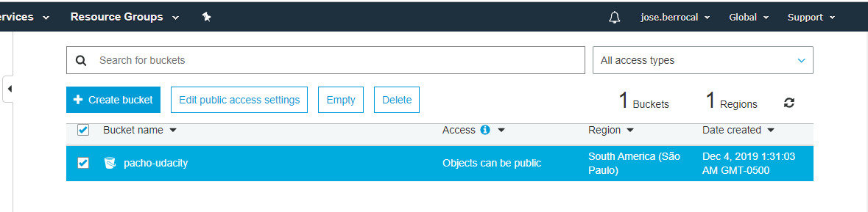

 Files uploaded to the newly created S3 bucket

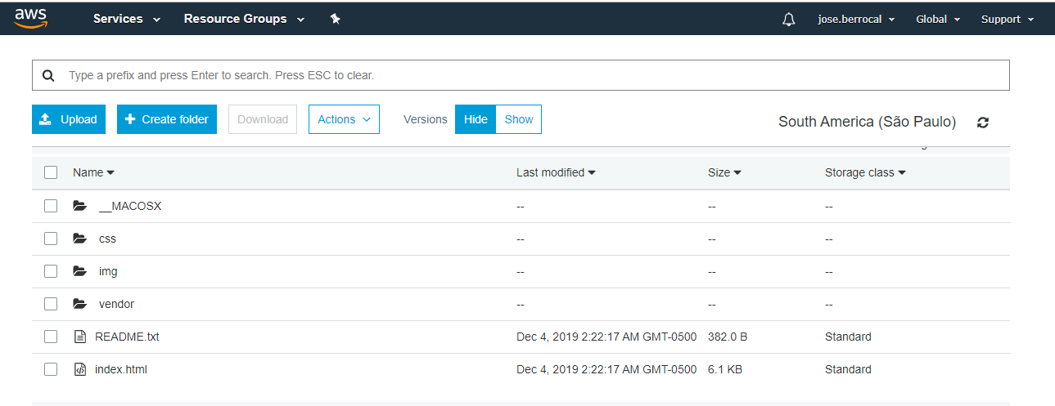

Support static website hosting

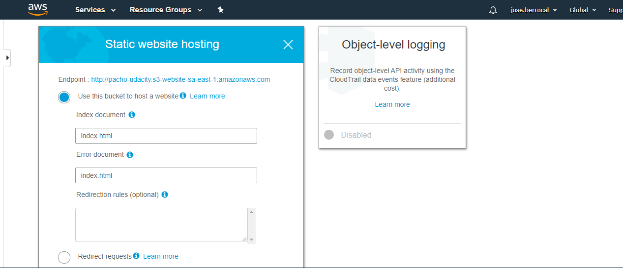

The IAM bucket policy that makes the bucket contents publicly accessible.

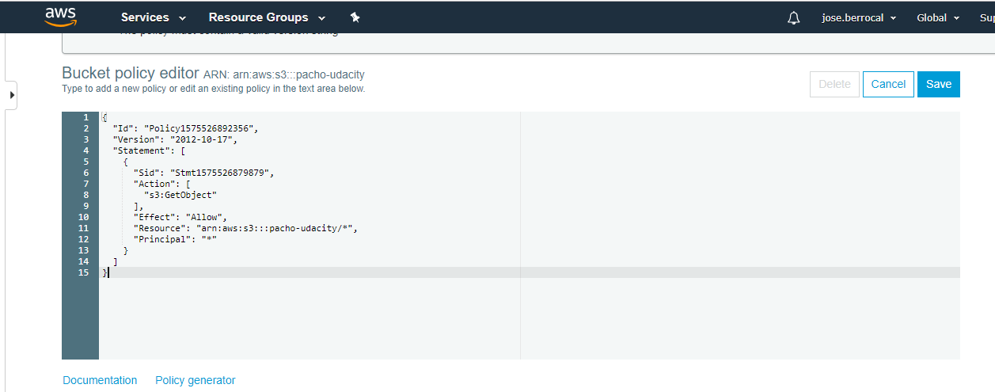

CloudFront has been configured

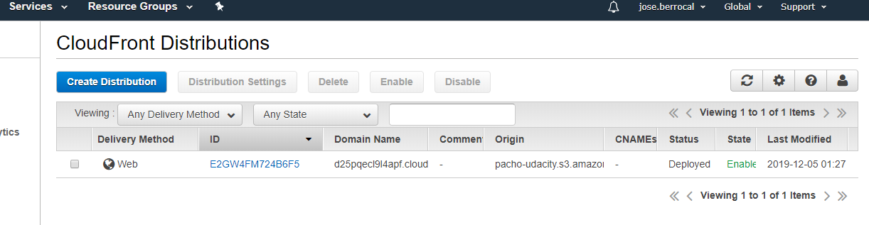

The website